CrytoCurrency Project-

1. Kinesis-

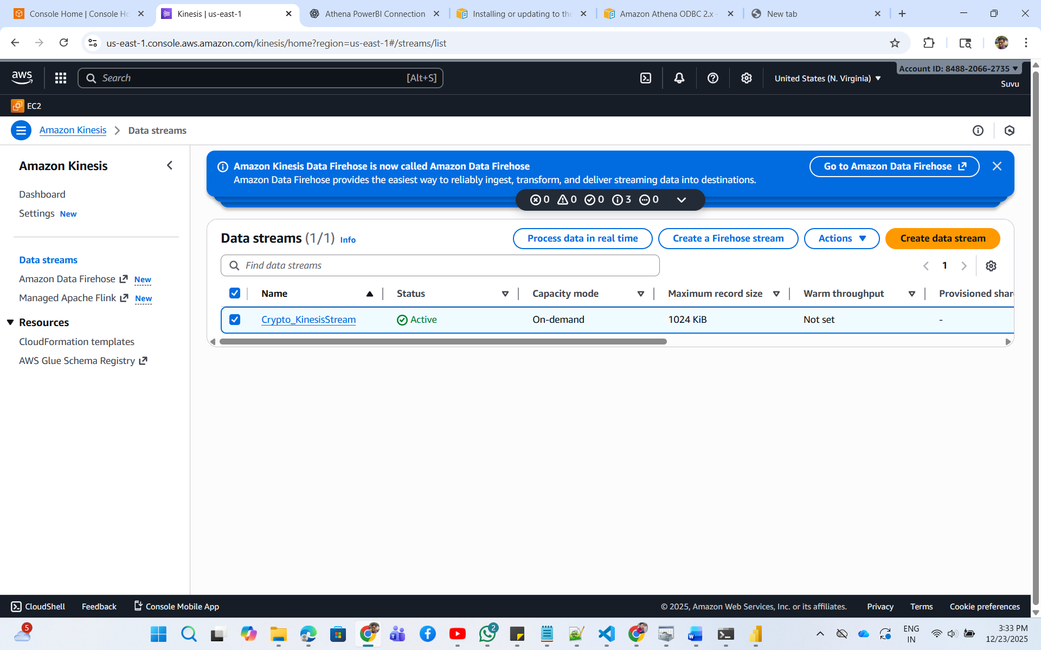

1. Lambda Functions-

LoadCrypto:

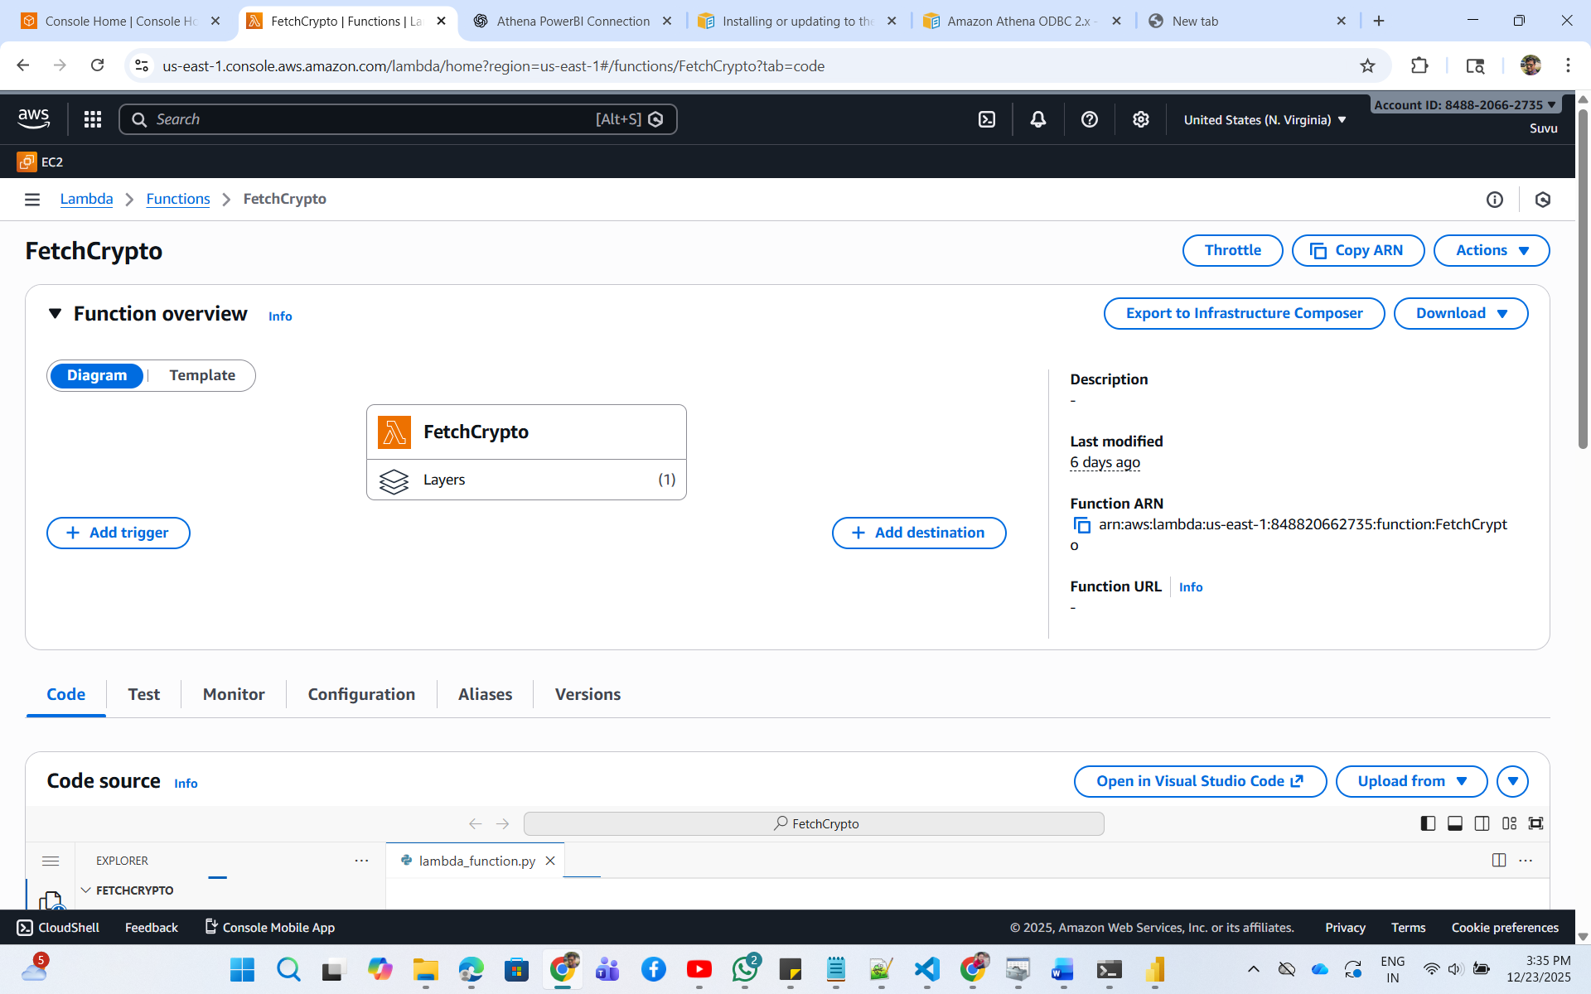

import json

import requests

import os

import boto3

def lambda_handler(event, context):

    # aws kinesis

    kinesis = boto3.client('kinesis', region_name='us-east-1')

    crypto_map = {

            'bitcoin': 'BTC',

            'ethereum': 'ETH',

            'solana': 'SOL',

            'cardano': 'ADA'

        }

    data = []

    try:

        for crypto_full,crypto_symbol in crypto_map.items():

            url = "https://api.coingecko.com/api/v3/simple/price?vs_currencies=usd&ids="+crypto_full+"&names="+crypto_full.capitalize()+"&symbols="+crypto_symbol

            headers = {"x-cg-demo-api-key": os.environ['coingecko_api_key']}

            response = requests.get(url, params={'vs_currencies': 'usd', 'include_market_cap': 'true', 'include_24hr_vol': 'true',

            'include_24hr_change': 'true'}, headers=headers)

            # print(response.text)

            kinesis.put_record(

                StreamName=os.environ['KINESIS_DATASTREAM'],

                Data=json.dumps(response.json()),

                PartitionKey=crypto_full

            )

            print("Data sent to Kinesis")

            data.append({

                'crypto': crypto_full,

                'price': response.json()[crypto_full]['usd'],

                'market_cap': response.json()[crypto_full]['usd_market_cap'],

                '24hr_vol': response.json()[crypto_full]['usd_24h_vol'],

                '24hr_change': response.json()[crypto_full]['usd_24h_change']

            })

        print(data)

    except Exception as e:

        print(e)

        raise e

        exit(1)

    return {

        'statusCode': 200,

        'body': json.dumps('Executed Successfully!!')

    }

Lambda2- LoadCryptoS3

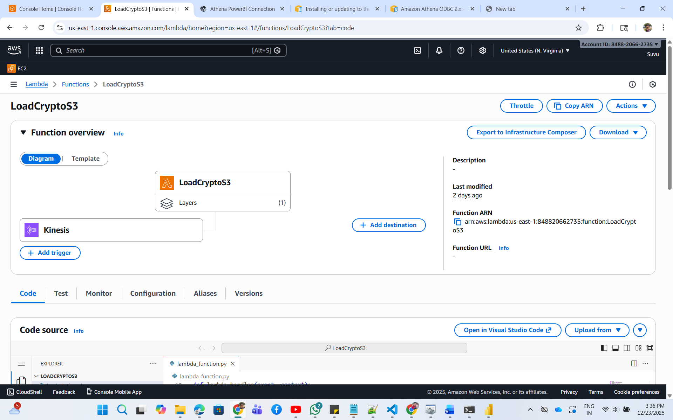

import json

import boto3

from collections import defaultdict

import base64

from datetime import datetime

import logging

logger = logging.getLogger()

logger.setLevel(logging.INFO)

s3 = boto3.client('s3')

# CONFIG

BUCKET = "suvus3bucket"

WINDOW = 10  # moving average window

price_buffer = defaultdict(list)  # in-memory buffer

def lambda_handler(event, context):

    """

    Lambda triggered by Kinesis.

    Each record from Kinesis should contain JSON like:

    {

        "bitcoin": {

            "usd": 87037,

            "usd_market_cap": 1738332206735.3381,

            "usd_24h_vol": 45102475159.332664,

            "usd_24h_change": 1.5662022163293967

        }

    }

    """

    logger.info("EVENT = %s", json.dumps(event))

    if 'Records' not in event:

        logger.error("Not a Kinesis event: %s", event)

        return {

            'statusCode': 400,

            'body': 'Not a Kinesis event'

        }

    for record in event['Records']:

        # Kinesis data is base64 encoded

        payload = base64.b64decode(record['kinesis']['data'])

        data = json.loads(payload)

        logger.info("Decoded payload: %s", data)

        # Extract crypto info

        crypto_id = list(data.keys())[0]      # 'bitcoin'

        crypto_data = data[crypto_id]

        ts = datetime.utcnow()  # current processing time

        price_usd = crypto_data['usd']

        market_cap_usd = crypto_data['usd_market_cap']

        hr24_volume = crypto_data['usd_24h_vol']

        hr24_change = crypto_data['usd_24h_change']

        # --- Compute simple moving average ---

        price_buffer[crypto_id].append(price_usd)

        if len(price_buffer[crypto_id]) > WINDOW:

            price_buffer[crypto_id].pop(0)

        ma_10 = sum(price_buffer[crypto_id]) / len(price_buffer[crypto_id])

        # --- Compute simple signal ---

        signal = "BUY" if price_usd > ma_10 else "SELL"

        # --- Prepare record for S3 ---

        enriched = {

            "timestamp": ts.isoformat() + "Z",

            "symbol": crypto_id,

            "price": price_usd,

            "ma_10": round(ma_10, 2),

            "signal": signal,

            "market_cap_usd": market_cap_usd,

            "hr24_volume": hr24_volume,

            "hr24_change": hr24_change

        }

        # --- Generate S3 key (partitioned by symbol/year/month/day) ---

        key = (

            f"symbol={crypto_id}/"

            f"year={ts.year}/month={ts.month:02d}/day={ts.day:02d}/"

            f"data-{int(ts.timestamp())}.json"

        )

        # --- Write to S3 ---

        s3.put_object(

            Bucket=BUCKET,

            Key=key,

            Body=json.dumps(enriched)

        )

        logger.info("Written record to S3: %s", key)

    return {"status": "success", "records_processed": len(event['Records'])}

1. S3 bucket-

Lambda loads to S3 bucket:

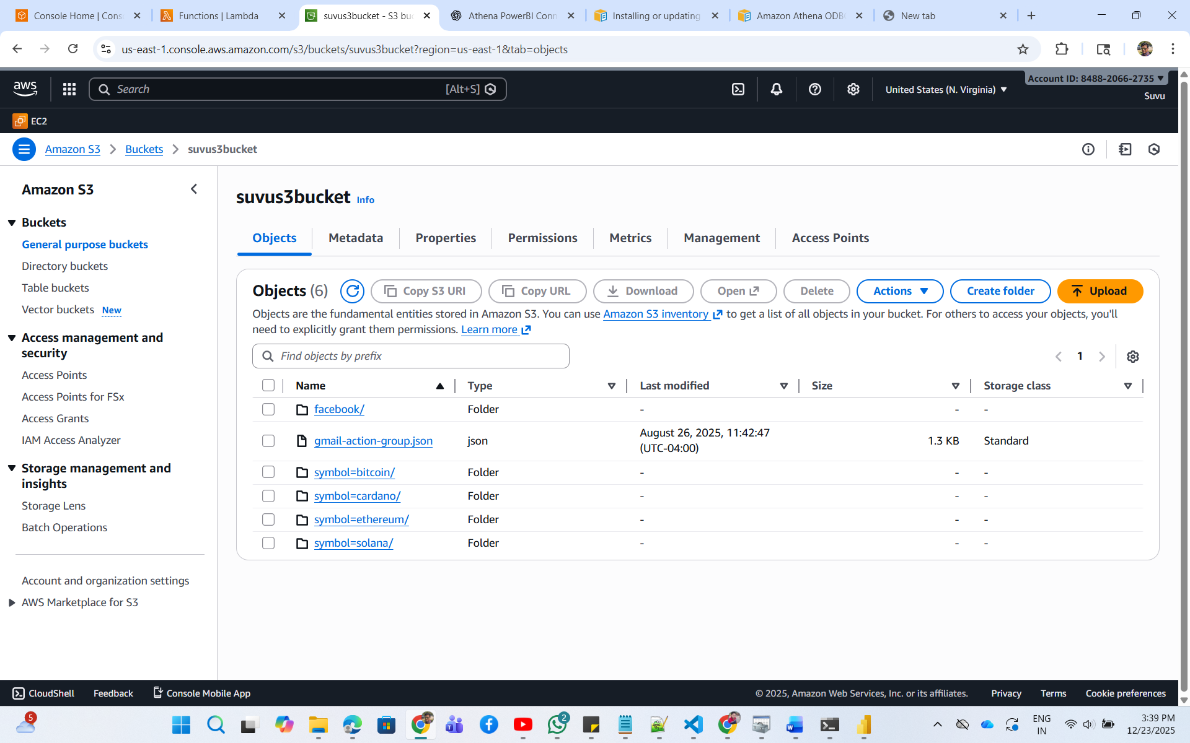

Athena Query results stores in S3-

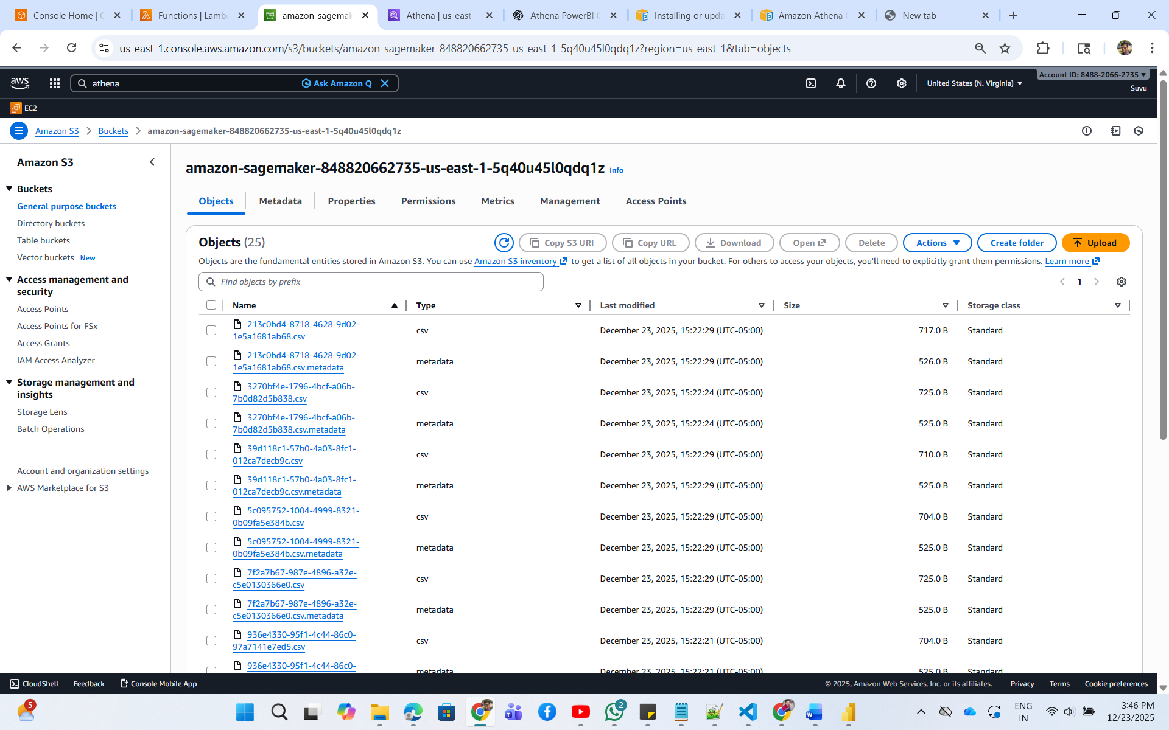

1. Glue Job- (Crawler Job)

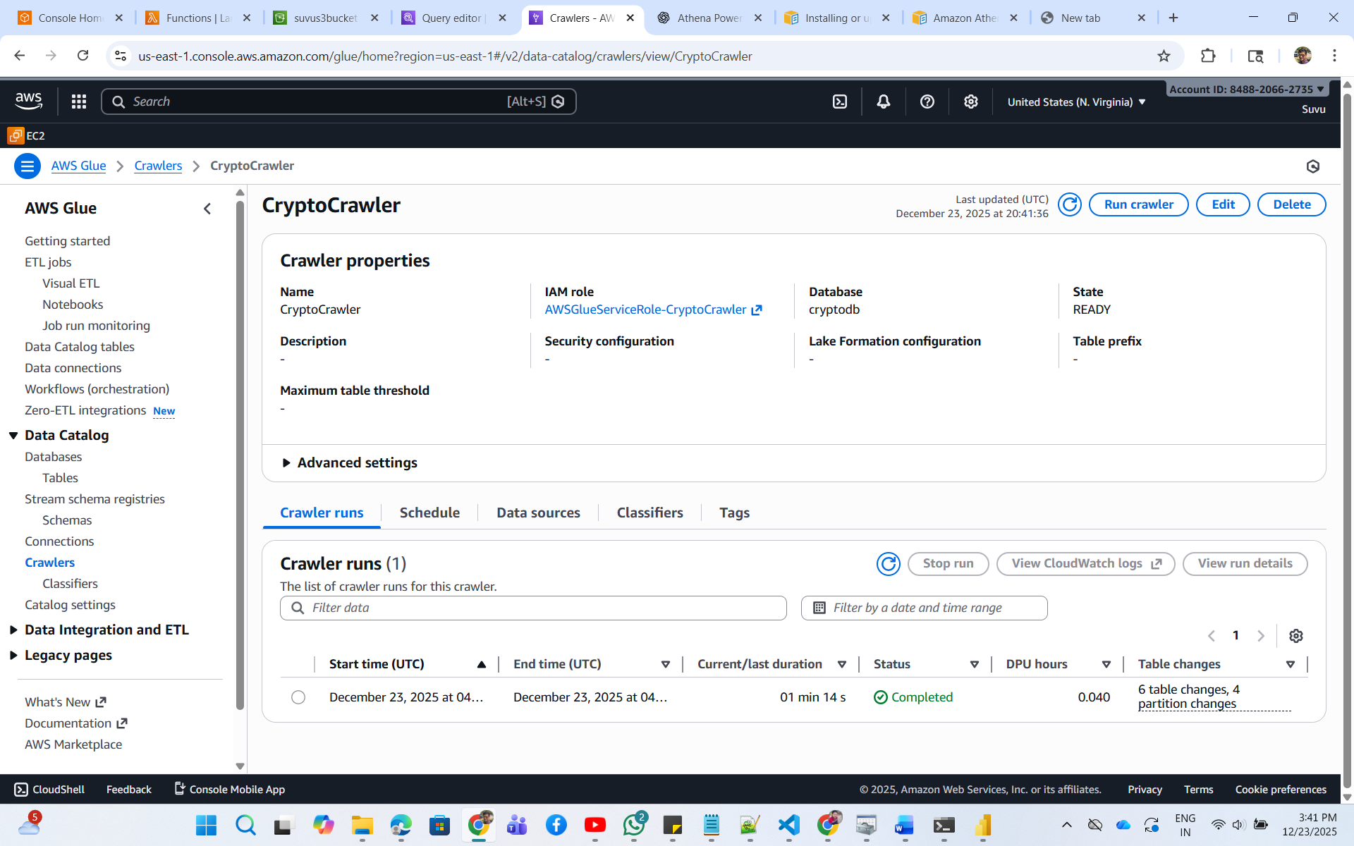

DB and Tables-

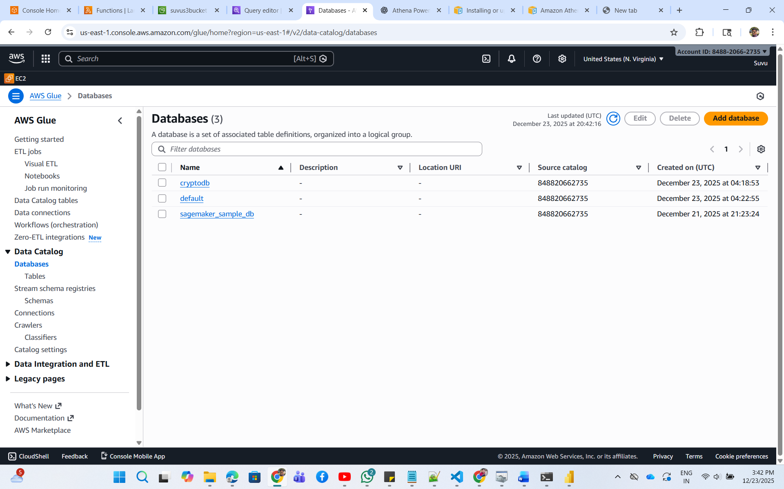

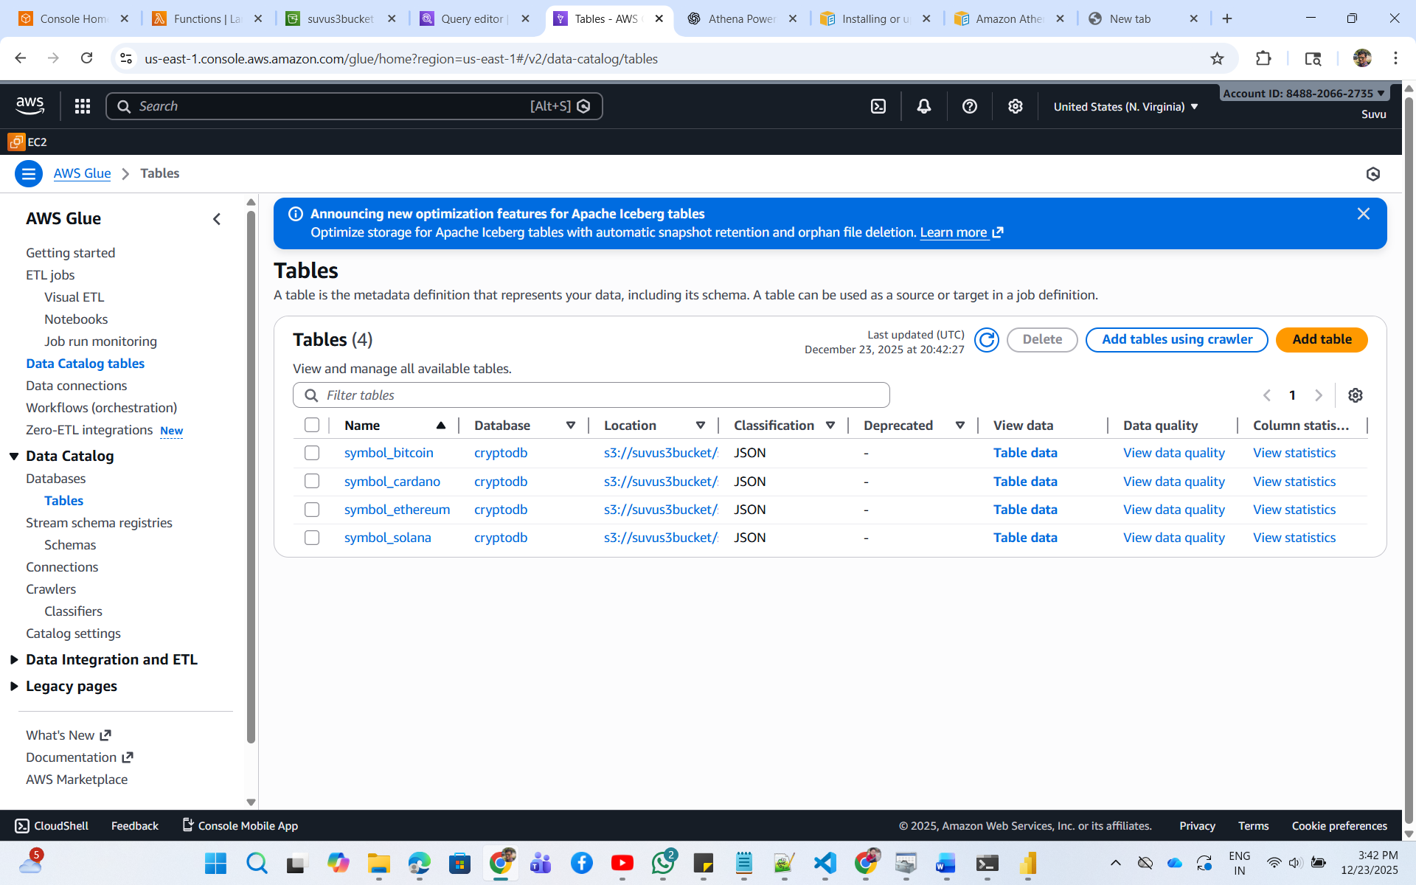

1. Athena-

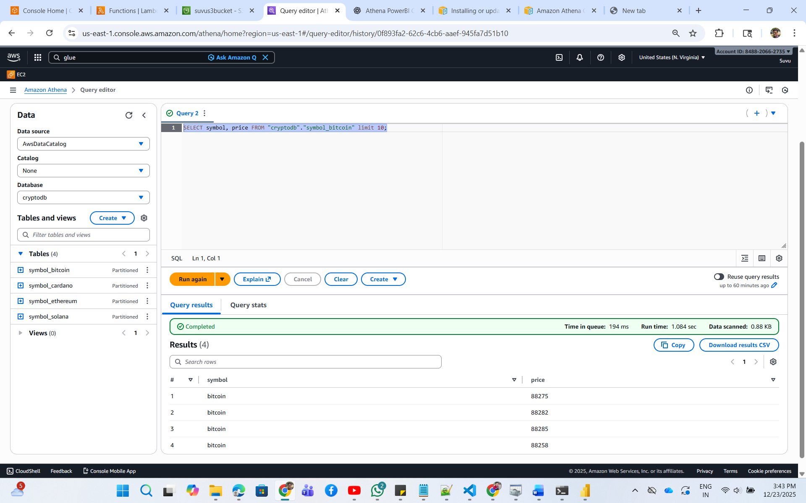

1. Athena ODBC Connection-

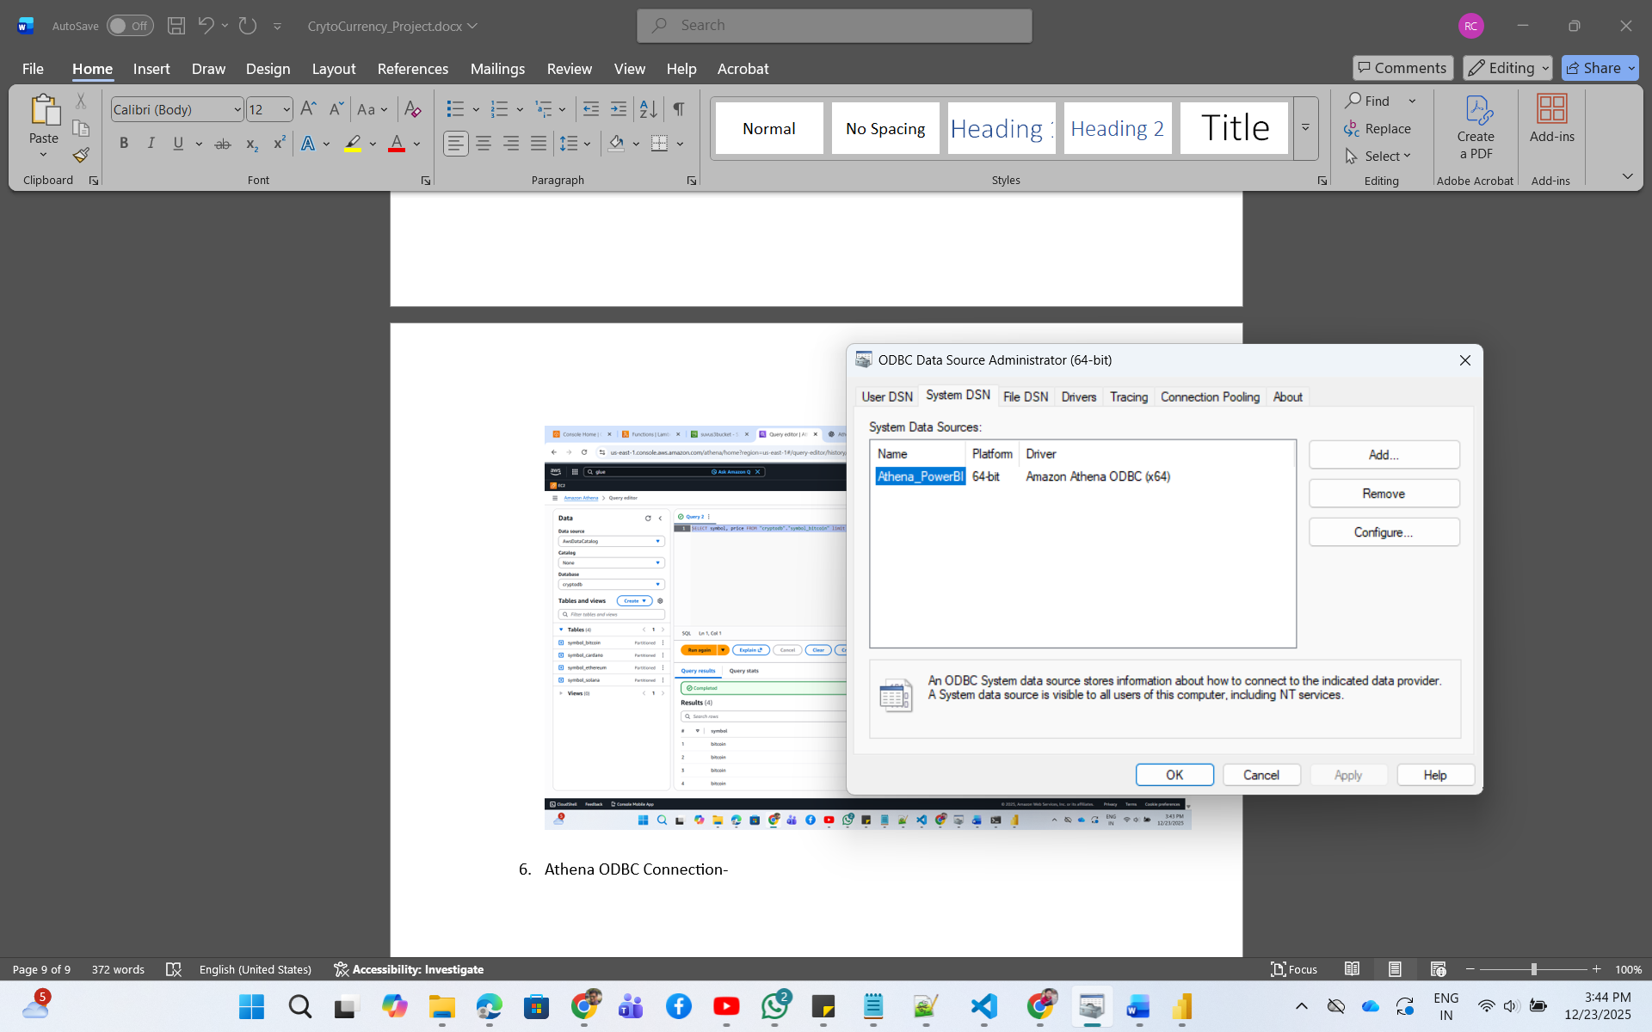

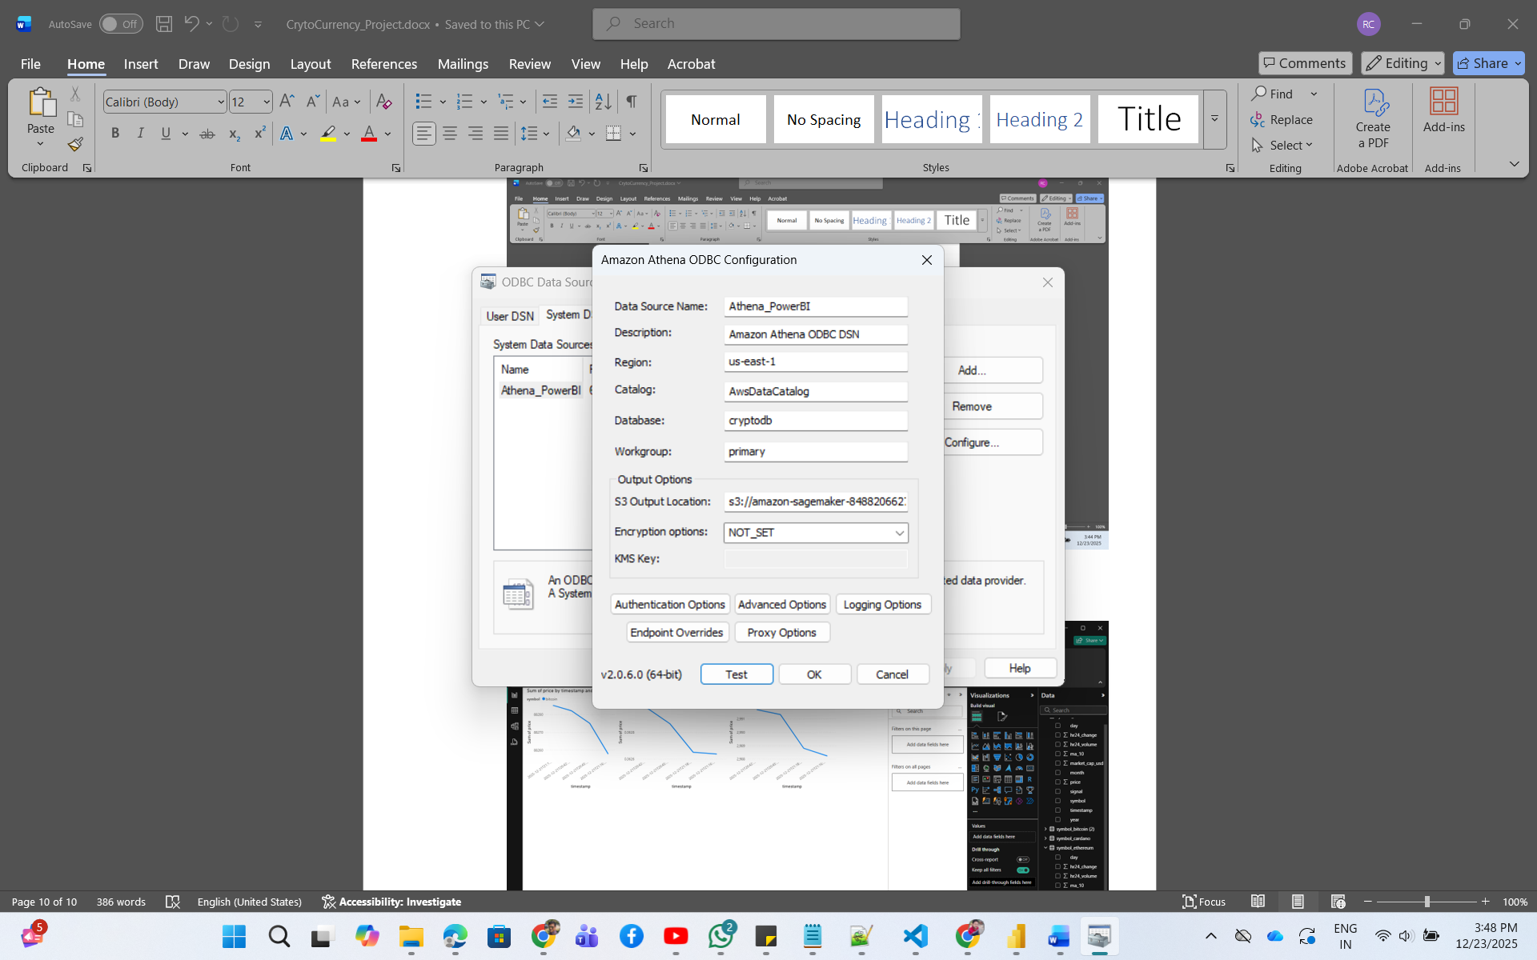

1. PowerBI report-

